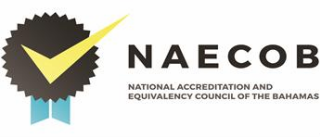

RECOGNITION COSTS

The cost associated with recognition is $2,500.00 per annum. Please note that all fees should be paid via wire transfer to:

The National Accreditation & Equivalency Council of The Bahamas.

Wiring instructions are:

J P Morgan Chase Bank
New York, New York
SWIFT: CHASUS33
Fed Wire/ABA 021000021

Bank of The Bahamas Limited
Harold Road Branch
Nassau, Bahamas

SWIFT CODE BOTBBSNS
A/C # 0011188414

For further final credit to:

The National Accreditation & Equivalency Council of The Bahamas
RND Plaza West, JFK Drive
P.O. Box N-3913
Nassau, N.P., The Bahamas
Tel # 1-242-328-8872 /3

Account number # 122 0000 199
Harold Road Branch #166

